|  |  |
| --- | --- |
| Name : [Mike](mailto:johnvincentdallego082193@gmail.com) Leanard Cabacaba | Section : BSIT 3C |
| Assignment No : | Submission Date : April 04, 2024 |
| Assignment Title: Guessing Number Game | |

**Code :**

**HTML FILE**

*<!DOCTYPE html>*

*<html lang="en">*

*<head>*

*<meta charset="UTF-8">*

*<meta name="viewport" content="width=device-width, initial-scale=1.0">*

*<title>Number Guessing Game</title>*

*<link rel="stylesheet" href="index.css">*

*</head>*

*<body>*

*<div class="container">*

*<h1>Number Guessing Game</h1>*

*<p>Enter a number between 1 and 10:</p>*

*<input type="text" id="userGuess"></br>*

*<button onclick="checkGuess()">Submit Guess</button>*

*<p id="message"></p>*

*<p id="attempts"></p>*

*</div>*

*<script src="index.js"></script>*

*</body>*

*</html>*

**JS FILE**

*let randomNumber = generateRandomNumber();*

*let attempts = 0;*

*function generateRandomNumber() {*

*return Math.floor(Math.random() * 10) + 1;*

*}*

*function restartGame() {*

*randomNumber = generateRandomNumber();*

*attempts = 0;*

*document.getElementById('userGuess').value = '';*

*document.getElementById('message').innerText = '';*

*document.getElementById('attempts').innerText = 'Attempts: 0';*

*document.getElementById('userGuess').disabled = false;*

*document.querySelector('button').disabled = false;*

*}*

*function checkGuess() {*

*let userGuess = document.getElementById('userGuess').value;*

*attempts++;*

*if (isNaN(userGuess) || userGuess < 1 || userGuess > 10) {*

*document.getElementById('message').innerText = "Invalid input: Please Input number between 1 - 10.";*

*} else {*

*userGuess = parseInt(userGuess);*

*if (userGuess === randomNumber) {*

*document.getElementById('message').innerText = `Congratulations! You've won in ${attempts} attempts.`;*

*disableInputAndButton();*

*setTimeout(restartGame, 2000); // Restart game after 2 seconds*

*} else if (userGuess < randomNumber) {*

*document.getElementById('message').innerText = "Too low! Try again.";*

*} else {*

*document.getElementById('message').innerText = "Too high! Try again.";*

*}*

*}*

*document.getElementById('attempts').innerText = `Attempts: ${attempts}`;*

*}*

*function disableInputAndButton() {*

*document.getElementById('userGuess').disabled = true;*

*document.querySelector('button').disabled = true;*

*}*

**CSS FILE**

*body {*

*font-family: Arial, sans-serif;*

*background-color: #f0f0f0;*

*}*

*.container {*

*max-width: 400px;*

*margin: 50px auto;*

*padding: 20px;*

*background-color: #fff;*

*border-radius: 5px;*

*box-shadow: 0 0 10px rgba(0, 0, 0, 0.1);*

*text-align: center;*

*}*

*h1 {*

*margin-bottom: 20px;*

*}*

*button {*

*padding: 10px 20px;*

*margin-top: 10px;*

*background-color: black;*

*color: #fff;*

*border: none;*

*border-radius: 5px;*

*cursor: pointer;*

*}*

*button:hover {*

*background-color: gray;*

*border:none;*

*}*

**SCREENSHOT**

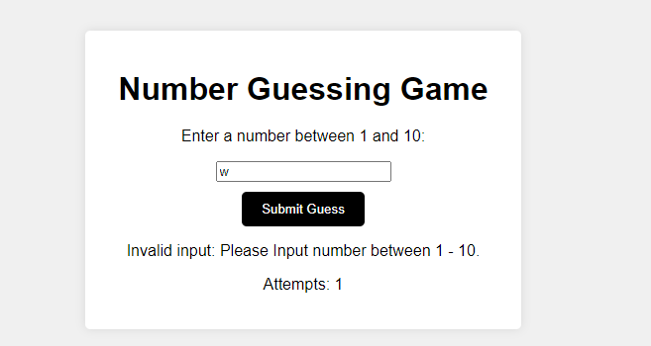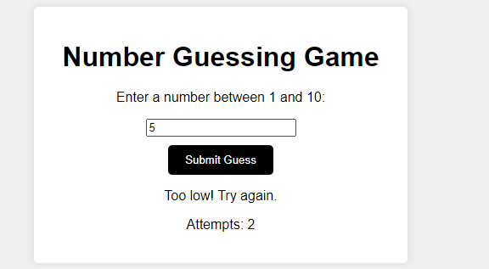

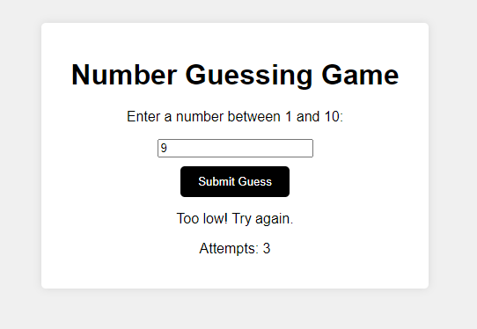

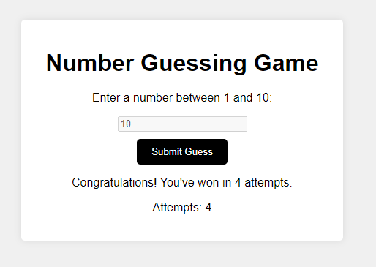

**Dictionary:***:*

* **attempts++** - Increment

**Syntax** : **attempts++;**

**Parameter** : Integers.

let attempts = 6;

attempts++;

console.log(attempts);

output: 7;

* **<div>** - stands for "division" or "divider," indicating its purpose to divide or group content   
  within a web page.

**Syntax** : <div class="container">

Contents…

</div>

**Parameter** : class=” container”

* **||** – is logical OR operator.

**Syntax** : if (isNaN(userGuess) || userGuess < 1 || userGuess > 10)**Parameter:**num(float,int,string,variable){

…..

}

* **:hover** - selector is used to select elements when you mouse over them.

**Syntax** : button:hover

**Parameters**: none.

* **setTimeout()** - method calls a function after a number of milliseconds.  
    
  1000 = 1 seconds. **Syntax** : setTimeout(restartGame, 2000);

**Parameters:**function and milliseconds.